Distributed Web Crawler
CSE 5306 Spring 2015, Section 1

Team Members

Nishanth Terikere Vasudeva
1001011898
nishanth.terikerevasudeva@mavs.uta.edu

Puneeth Umesh Bharadwaj
1001106478
puneeth.bharadwaj@mavs.uta.edu

Tarun Ande
1001108289
tarun.ande@mavs.uta.edu

Introduction

A web crawler is a program or automated script which browses the World Wide Web in a methodical, automated manner. Web crawlers are mainly used to create a copy of all the visited pages for later processing by a search engine that will index the downloaded pages to provide fast searches.

Crawlers can validate hyperlinks and HTML code. They can also be used for web scraping. Also, crawlers can be used to gather specific types of information from Web pages, such as harvesting e-mail addresses
‐ discuss background information about the project.
* What is the goal of this project?
The main aim of this project is to implement a web crawler is distributed level.
‐ give examples (use cases) to illustrate the expected end product
‐ a very brief summary of your work
* a high‐level description about the design
* the functionalities
‐ organization of this report

Related Work
Section 2: Related Work
‐ There could be many real systems out there. List and brief discuss them.

- Bingbot is the name of Microsoft's Bing webcrawler. It replaced Msnbot.

- Googlebot is described in some detail, but the reference is only about an early version of its architecture, which was based in C++ and Python. The crawler was integrated with the indexing process, because text parsing was done for full-text indexing and also for URL extraction. There is a URL server that sends lists of URLs to be fetched by several crawling processes. During parsing, the URLs found were passed to a URL server that checked if the URL has been previously seen. If not, the URL was added to the queue of the URL server.

- WebCrawler was used to build the first publicly available full-text index of a subset of the Web. It was based on lib-WWW to download pages, and another program to parse and order URLs for breadth-first exploration of the Web graph. It also included a real-time crawler that followed links based on the similarity of the anchor text with the provided query.
- Scrapy, an open source webcrawler framework, written in python (licensed under BSD).

System Overview
Section 3: System Overview
‐ An overview of the design (use a picture to illustrate the architecture)
‐ a brief discussion of each component
‐ how components interact with each other
Detailed Design
Section 4: Detailed Design
‐ the detailed design of each component
‐ list and discuss all challenges

The large volume implies that the crawler can only download a limited number of the Web pages within a given time, so it needs to prioritize its downloads. The high rate of change implies that the pages might have already been updated or even deleted.
* the challenges could be the design of individual components or the interaction between
different components
‐ explain what you do to solve these challenges
Implementation
Section 5: Implementation
‐ discuss how you implement the system, e.g., what tools to use.
The project will be implemented in python
‐ how the work is split among team members.

Theoretical/Simulation Study
Section 6: Theoretical/Simulation Study
‐ what is the communication overhead?
‐ what is the storage overhead?
‐ what is the computational overhead?
‐ any other aspects that people may be interested in.
A sample crawling script has been developed in python to observe how crawling works according to the structure of the web site, An URL from the University of Texas, Arlington has been Crawler and output has been observed.

Sample URL

http://www.uta.edu/uta/alpha-index.php
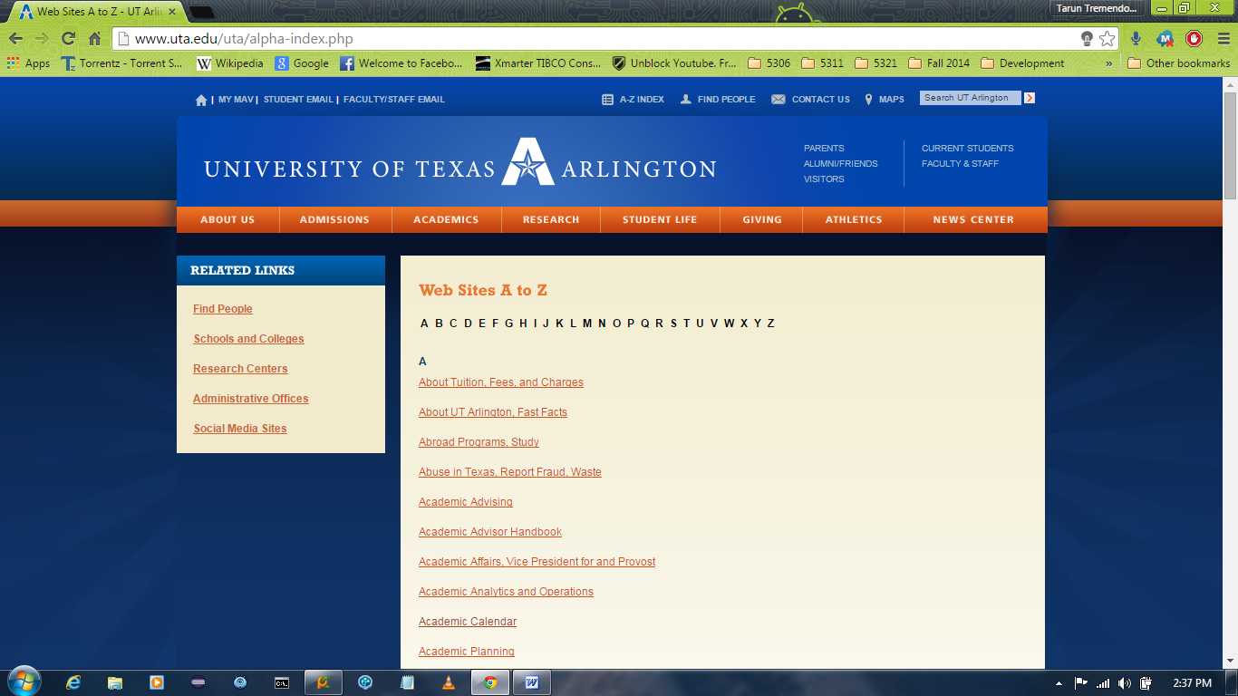

Sample Script

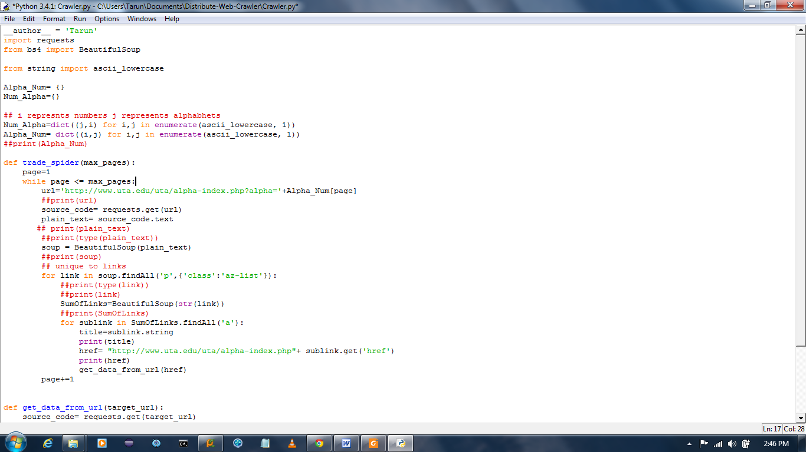

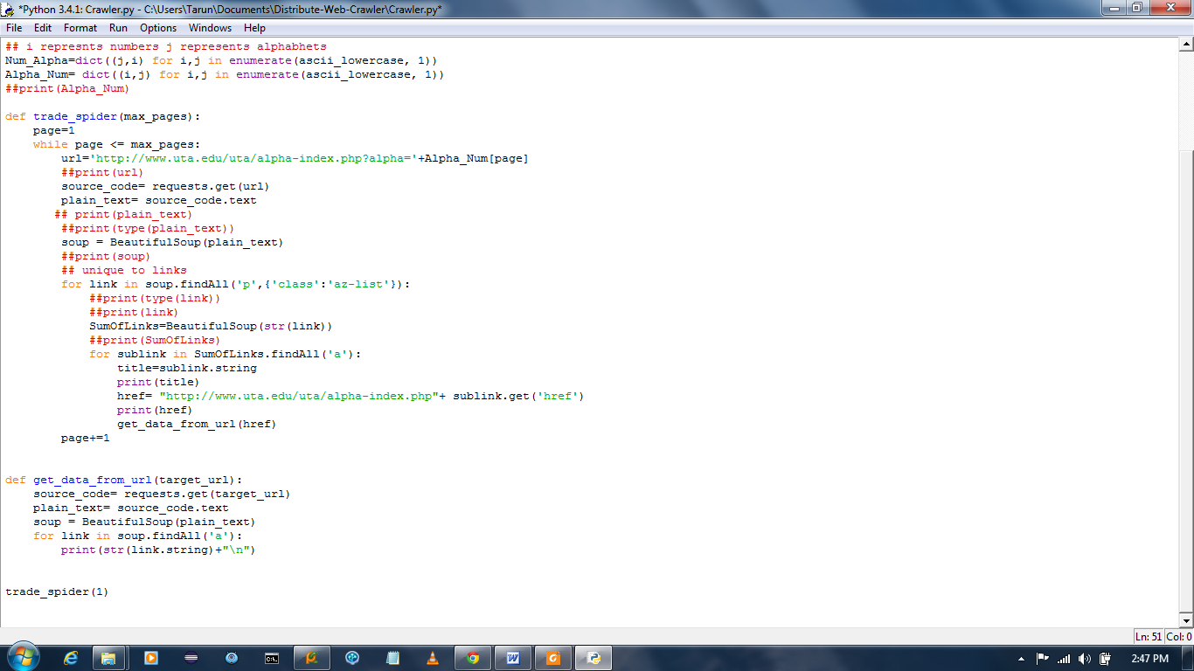

Observed Output

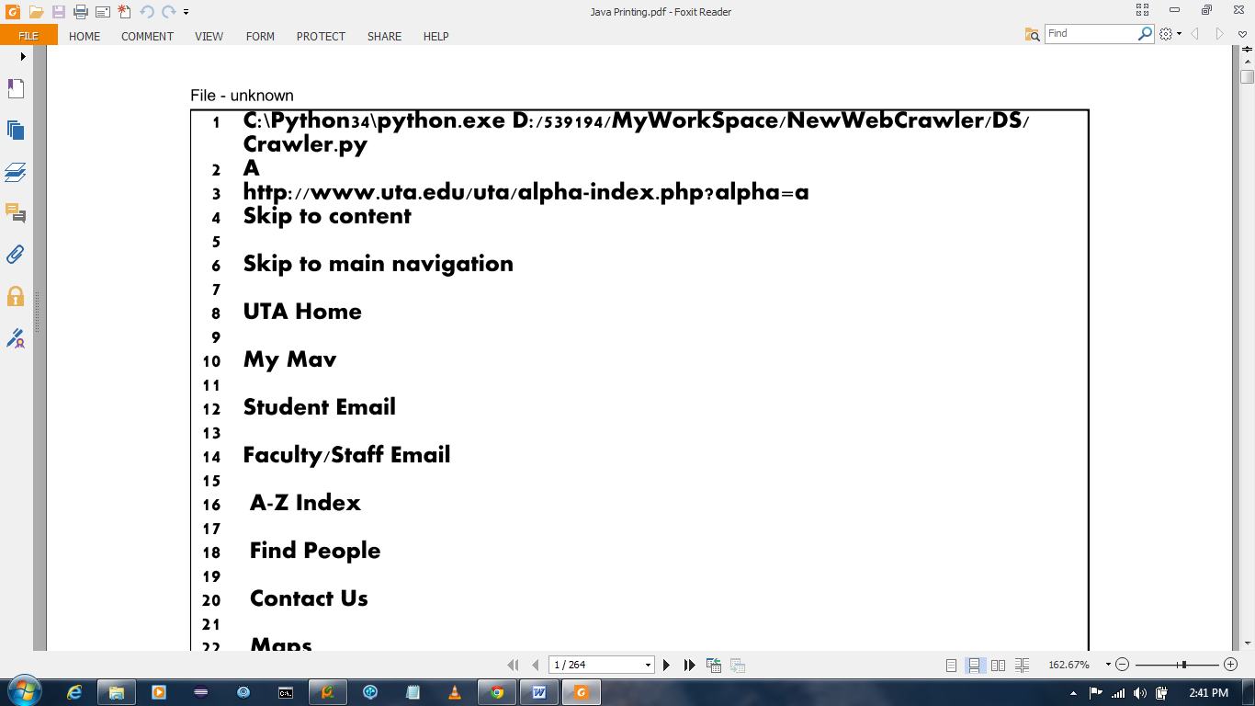

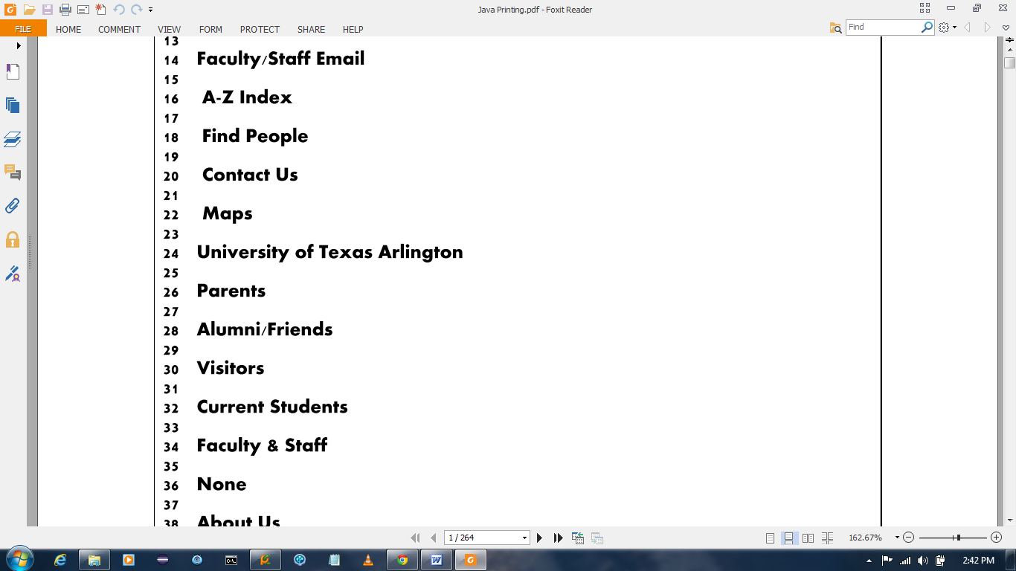

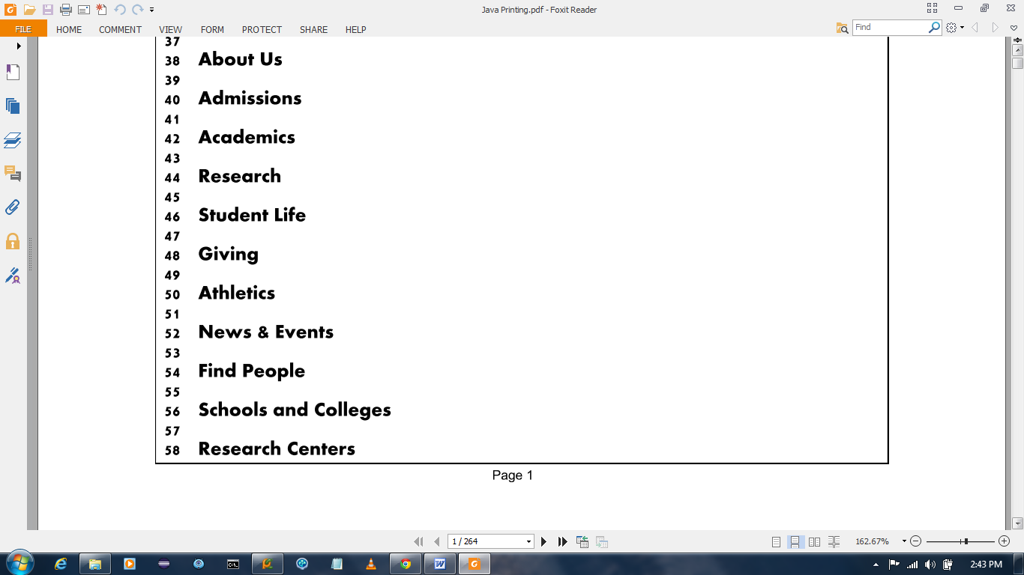

Future Work
Section 7: Future Work
‐ what you want to do in the future? (e.g., additional functionalities)

References
http://en.wikipedia.org/wiki/Web_crawler
http://www.sciencedaily.com/articles/w/web_crawler.htm

